**APPLIED PHYSICS LAB ASSIGNMENT NO. 3**

Name: “Muhammad Junaid Nazir”

Roll No.: “200828”

Department: “Computer Science (B S)”

Section: “B”

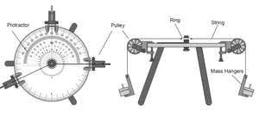**Finding Unknown Vector using Force Table**

Apparatus:

* Force Table
* Masses
* Strings

Procedure:

1. Setup the force table by using force table, strings and masses as shown above:
2. Place masses on the third hanger and keep on adding masses until the string finds an equilibrium point on the force table.
3. Note down the total mass in the third hanger.
4. 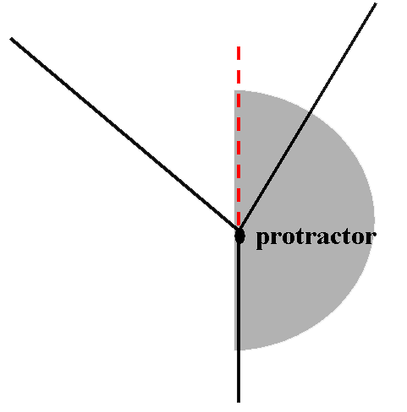Also note down the angle between 3rd string and vertical as following:
5. Convert mass into force and add 180˚ in measured angel.
6. Also calculate values of F3 and angel by using formulas. In the end compare both values.

Observations:

|  |  |  |  |  |  |  |  |  |  |
| --- | --- | --- | --- | --- | --- | --- | --- | --- | --- |
| No. of obs. | m1  ( kg ) | m2  ( kg ) | F1  (N) | Θ1 | F2  (N) | Θ2 | m3  ( kg ) | Direction of F3 | F3  (N) |
| 1. | 0.2 | 0.3 | 2 | 0˚ | 3 | 60˚ | 0.47 | 180˚+34˚ =  214˚ | 4.7 |
| 2. | 0.35 | 0.25 | 3.45 | 30˚ | 2.45 | 130˚ | 0.37 | 180˚+67˚ =  247˚ | 3.7 |

Calculations:

Case 1:

Given:

m1  = 200 g = 0.2 kg

m2 = 300 g = 0.3 kg

θ1  = 0˚ , θ2  = 60˚

Solution:

**Finding forces**

F1 = m1 g = (0.2)(10) = 2 N

F2 = m2 g = (0.3)(10) = 3 N

**Finding Components of F1**

F1X = F1 cos θ1 = 2 N

F1y = F1 sin θ1 = 0 N

**Finding Components of F2**

F2X = F2 cos θ2 = 1.5 N

F2y = F2 sin θ2 = 2.6 N

**Finding F3**

Method : 1 Method : 2

F3 = F1 + F2 F1x + F2x = 3.5 N

= 2 + 3 F1y + F2y = 2.6 N

F3 = 5 N F3  = 3.5 + 2.6

= 5 N

**Finding θ3 of F3**

θ3  = tan-1 y/x

= tan-1 2.6 / 3.5

θ3 = 36° => θ3  = 216°

Case 2:

Given:

m1  = 350 g = 0.35 kg

m2 = 250 g = 0.25 kg

θ1  = 30˚ , θ2  = 130˚

Solution:

**Finding forces**

F1 = m1 g = (0.35)(10) = 3.5 N

F2 = m2 g = (0.25)(10) = 2.5 N

**Finding Components of F1**

F1X = F1 cos θ1 = 3.03 N

F1y = F1 sin θ1 = 1.75 N

**Finding Components of F2**

F2X = F2 cos θ2 = -1.6 N

F2y = F2 sin θ2 = 1.91 N

**Finding F3**

Method : 1 Method : 2

F3 = F1 + F2 F1x + F2x = 2.43 N

= 3.5+2.5 F1y + F2y = 3.47 N

F3 = 6 N F3  = 2.43 + 3.47

= 6 N

**Finding θ3 of F3**

θ3  = tan-1 y/x

= tan-1 2.43 / 3.47

θ3 = 62° => θ3  = 242°